**CREATING A WEBSITE with the CMS known as WORDPRESS and WIX**

In this document we will be showing through screenshots some of the elements you need to know at the moment of creating a website (for free) in a designed CMS. Now all the CMS are located on the internet so we will be choosing two of the catalog. First, starting with Wordpress

**WORDPRESS Guide Create of a Website**

First you need to search on your search bar “wordpress.com”, once you searched it click on the button “Start now”.

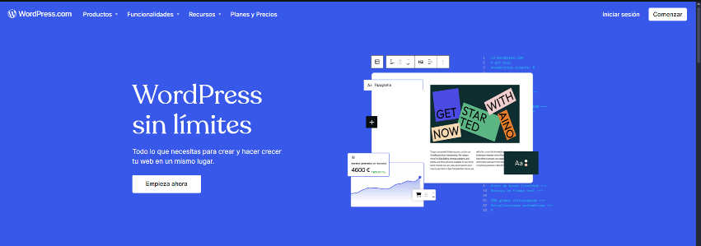

After that you will be redirected to the page that shows in the next image.

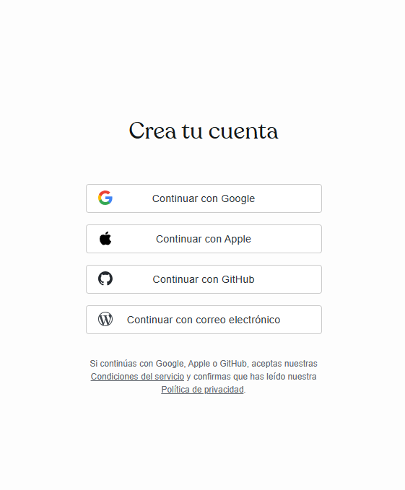

Once we created an account we are going to be requested to write a domain and select which offer you want to get, we will get the free one.

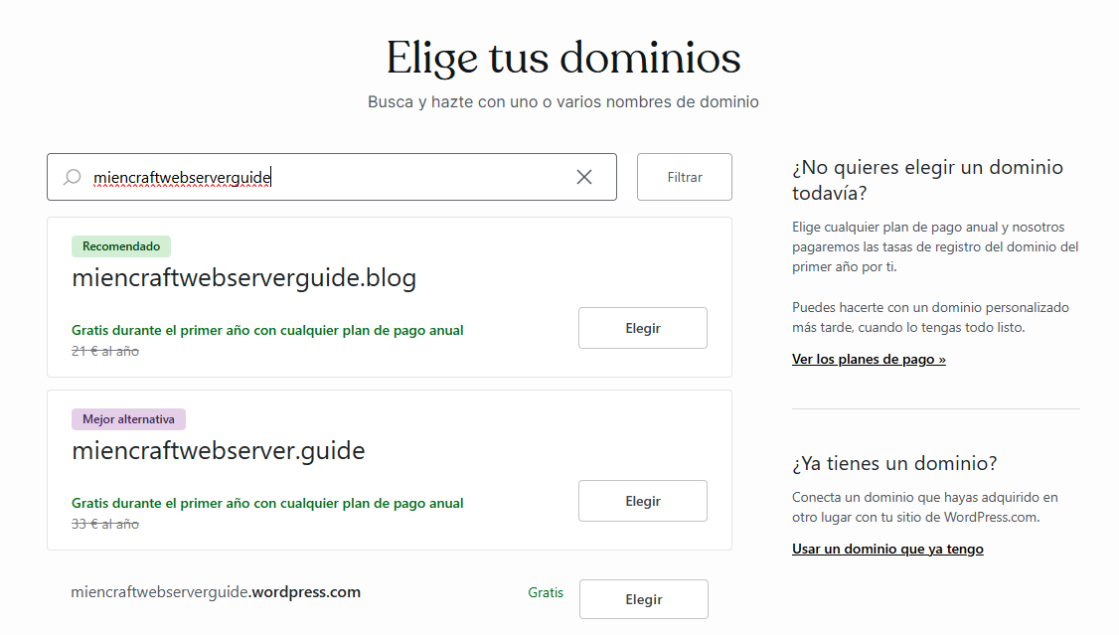

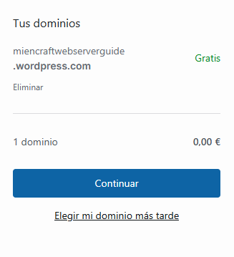

After that we will see another page to chose the subscription, we will choose the free one with no recharge

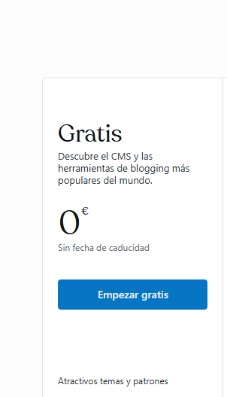

Then you need to talk about your objectives or goals you want to have in your page.

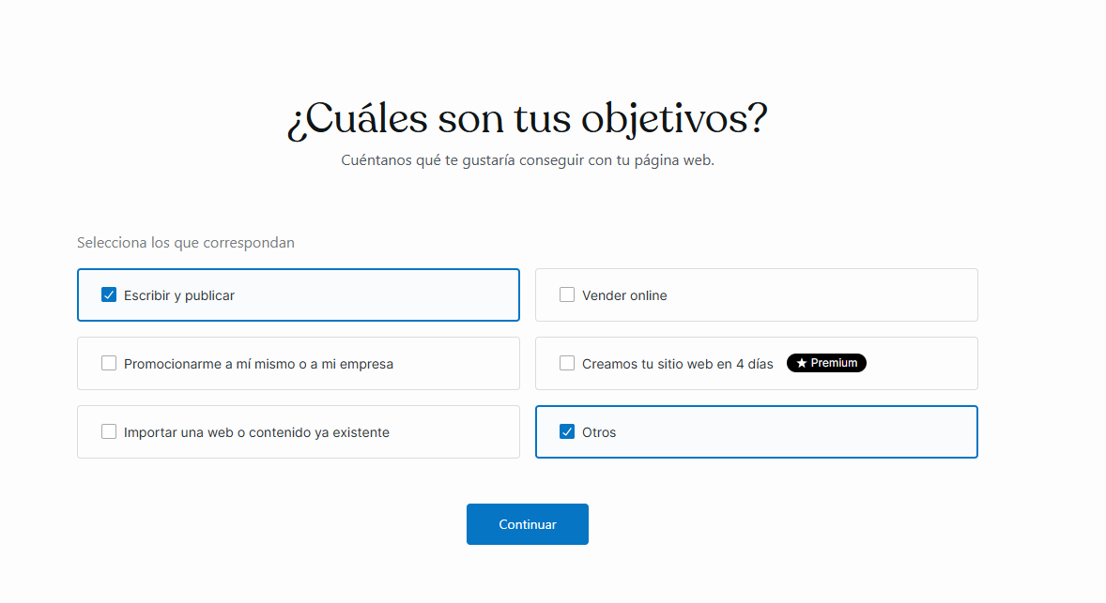

Then you need to name your page and a short description.

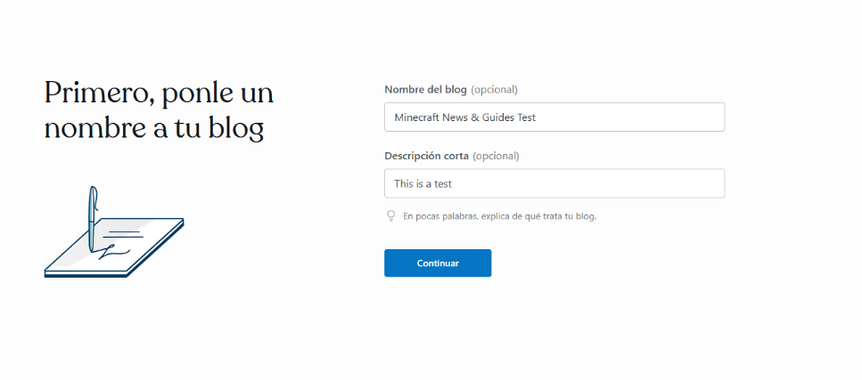

After this we will get three options to do, create a page from zero, select a design or import a design, we will select choose a design.



In this case we are going to do a Minecraft guide web page so we take the Minecraft page pre-design.

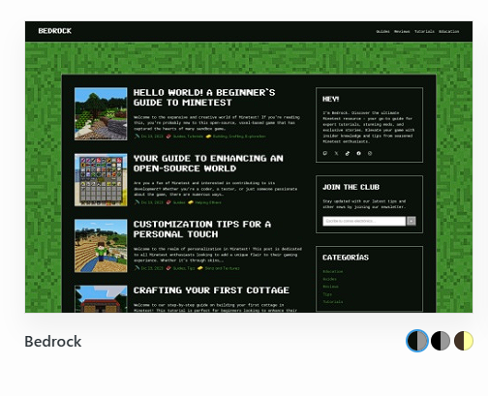

Then we will be asked to write our first post.

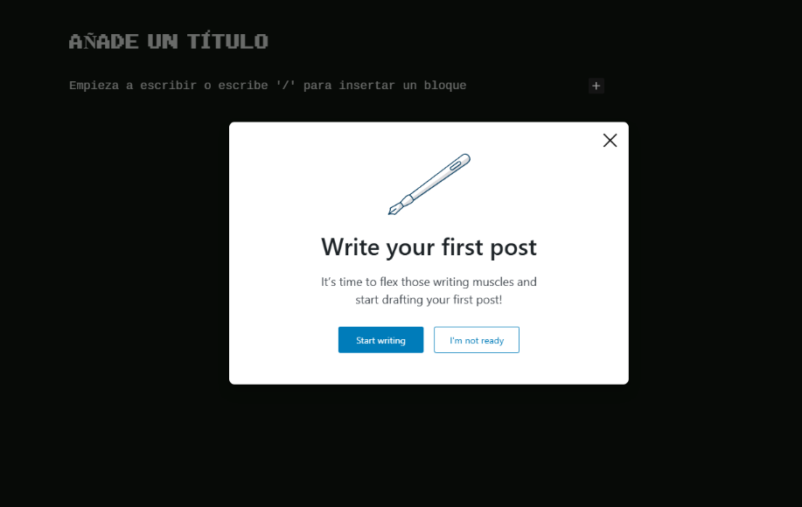

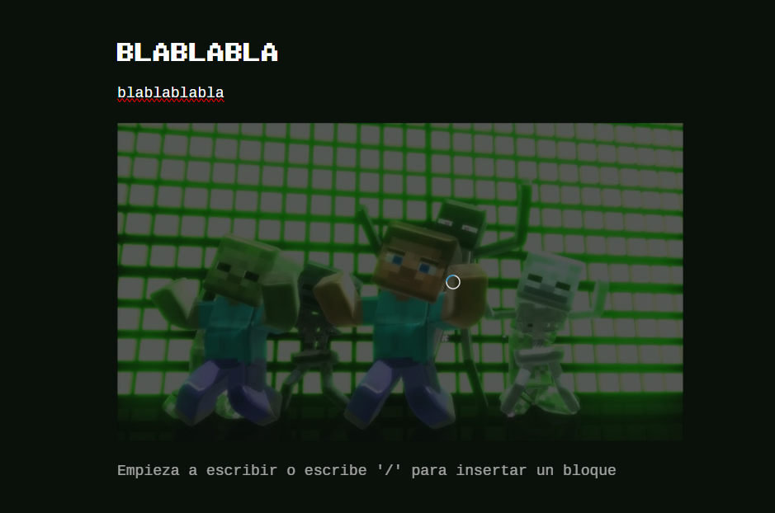

Now we publish it on the right up corner of the screen (our page is published after choosing the domain tho).



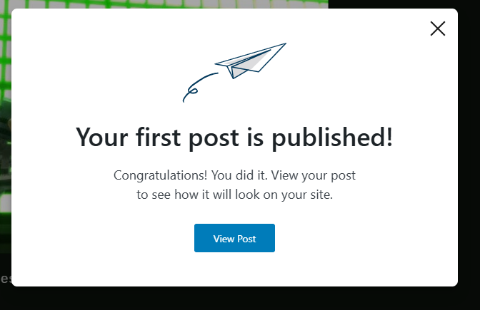

Now you can see your first subpage/post shown.

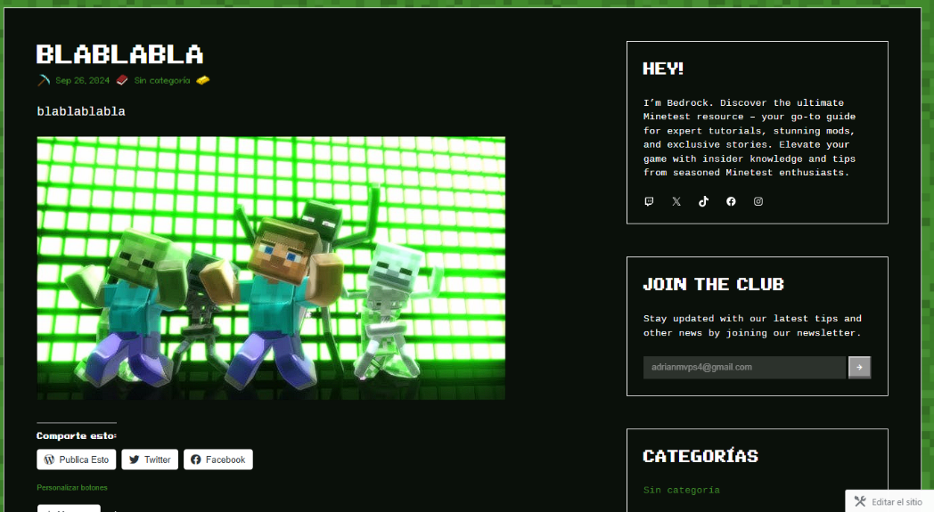

After that if you click on the left up corner where it is the name you gave to your page… You’ll be redirected to your home web page

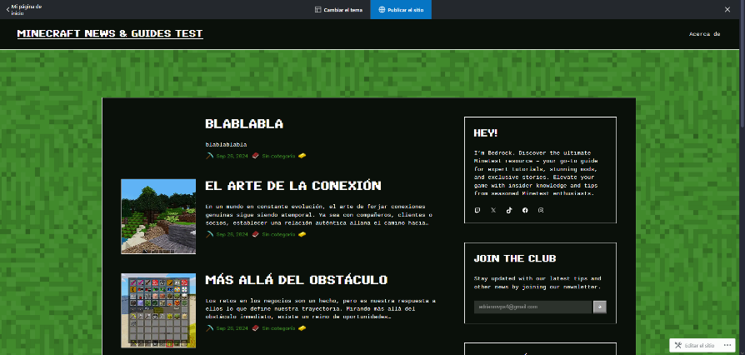

And… Congrats, you got your first page on CMS



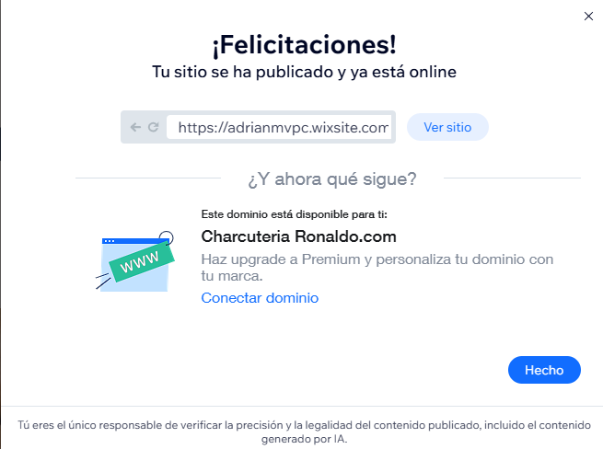

This is my web page done on Wordpress, has the home page and a subpage/post on it.

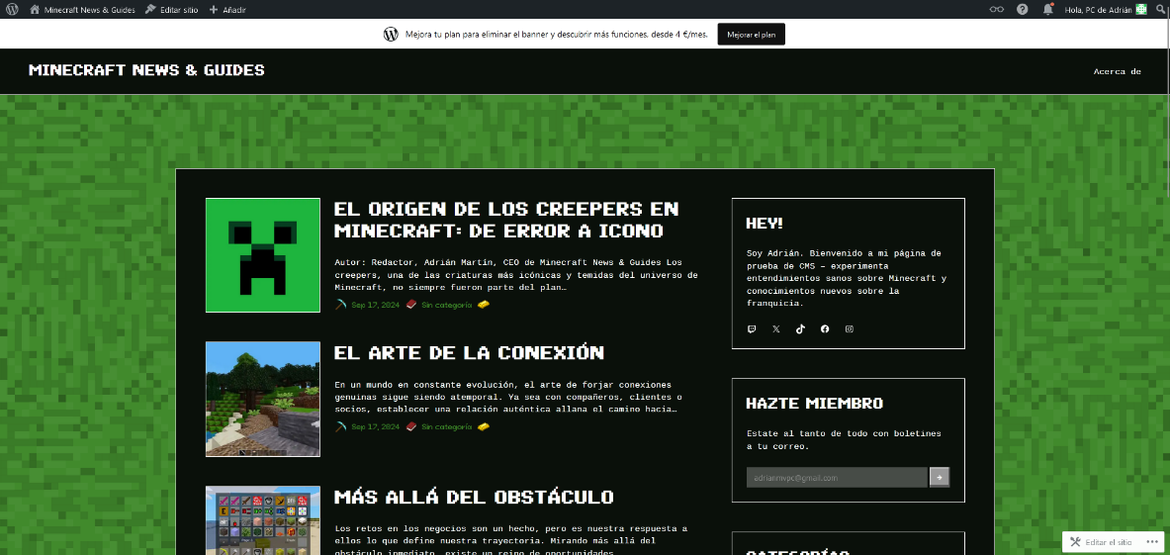

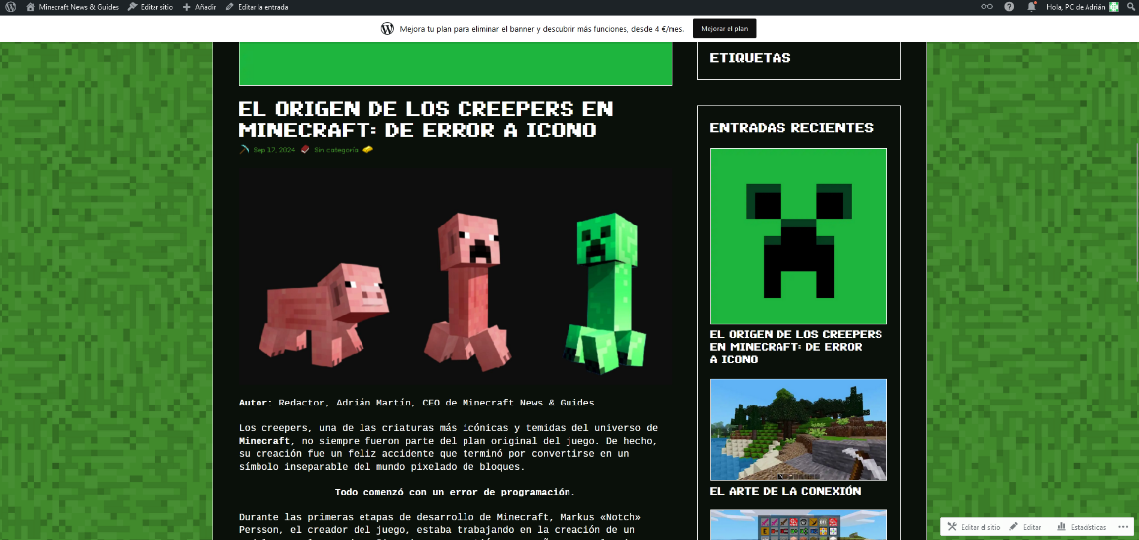

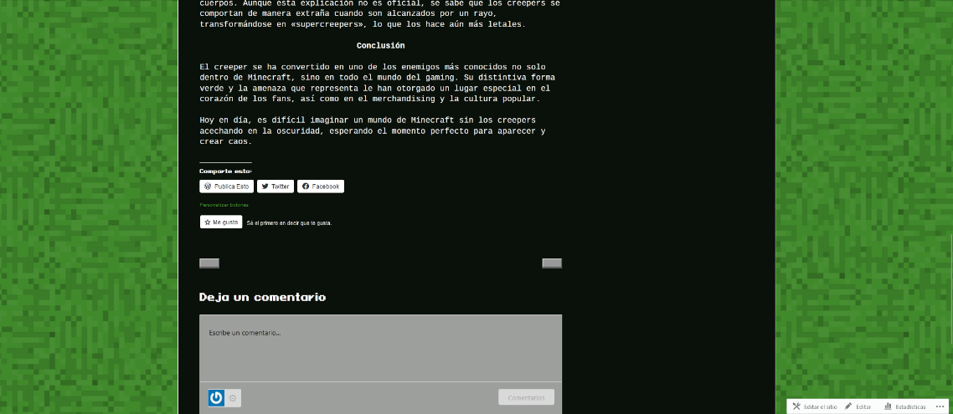

Here’s the link: <https://craftonmines.wordpress.com/>

**WIX Guide Create of a Website**

First you need to search on your search bar “wix.com”, once you searched it click on the button “Start”.

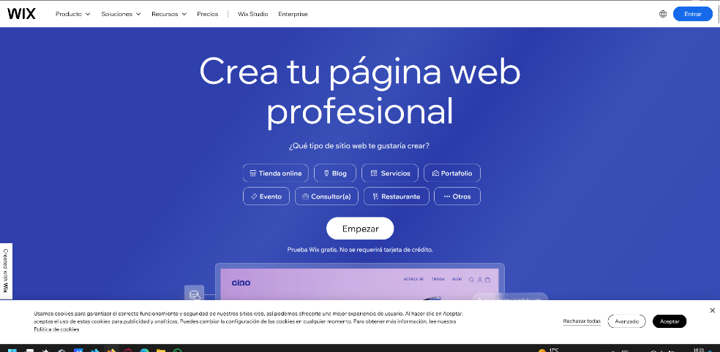

Once you hit the button you’ll have to register

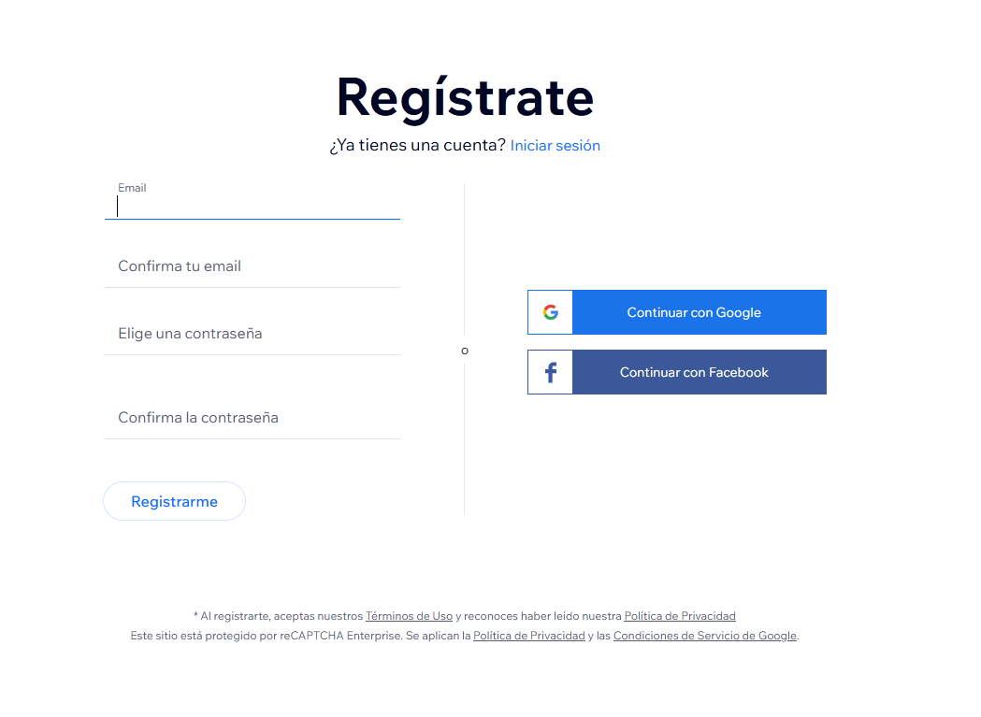

After that, you need to say for what purpose you are creating a website

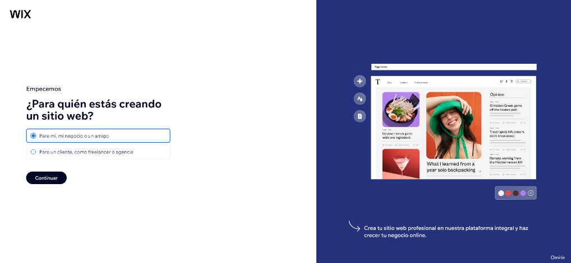

Then you’ll be recommended to use their AI to create the web page, which is what I did.



Then the AI will be asking some important things I will enumerate after this paragraph.

1:  
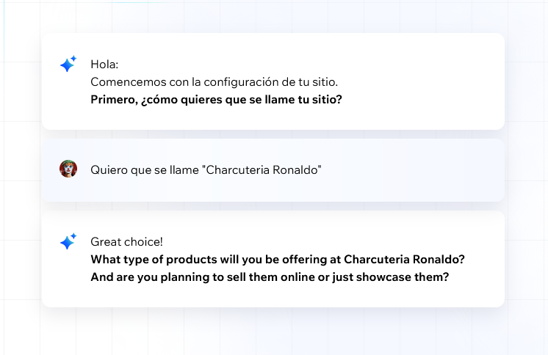

2:  
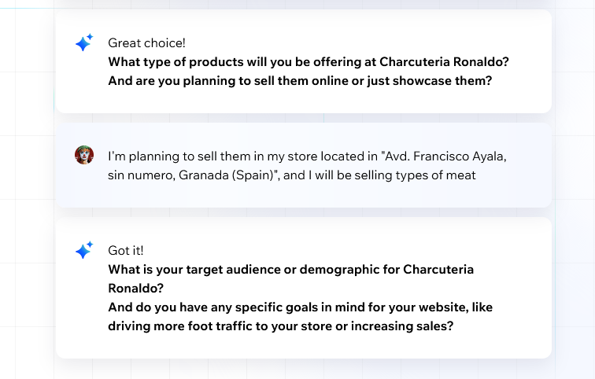

3:  
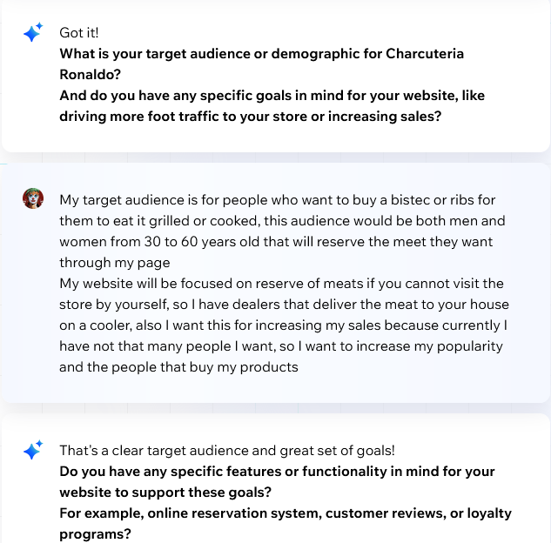

4:  
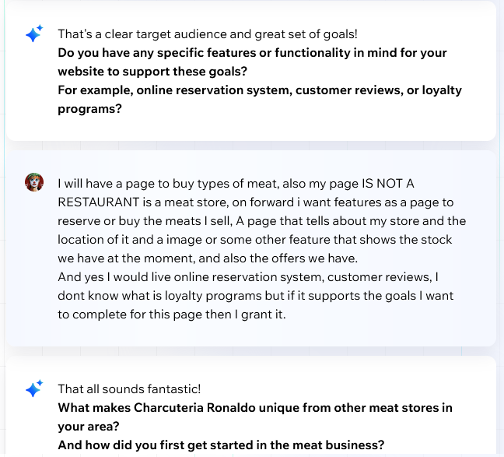

5:  
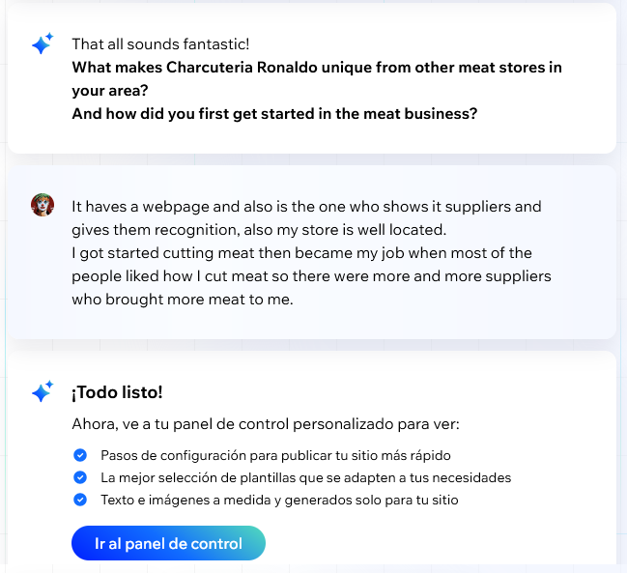

Now the AI has everything check and done for start creating it, as you can see in the next picture it says all the important things he will focus on.

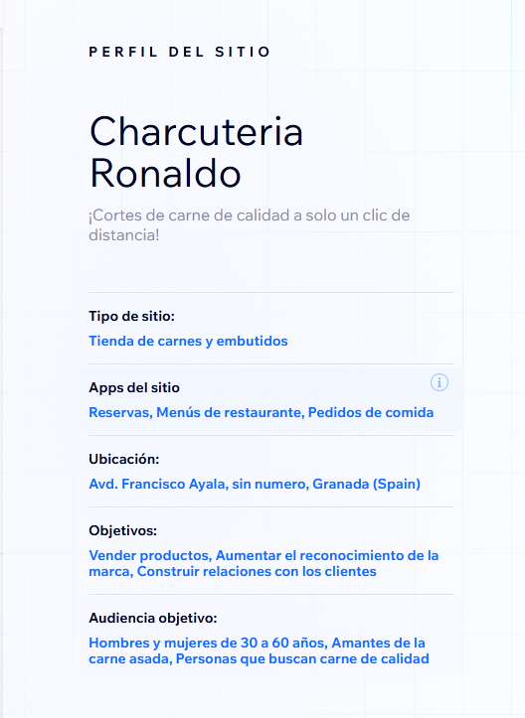

After this, the AI will be thinking, judging and creating the website, then you’ll be redirected now to your Wix Account home page for click the button on design your web page.

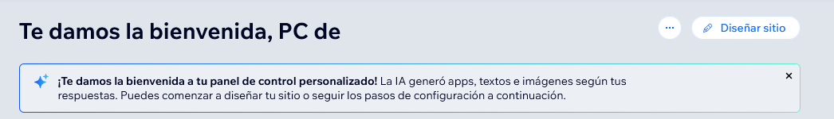

Now the AI will ask which design you like more; I selected this one…

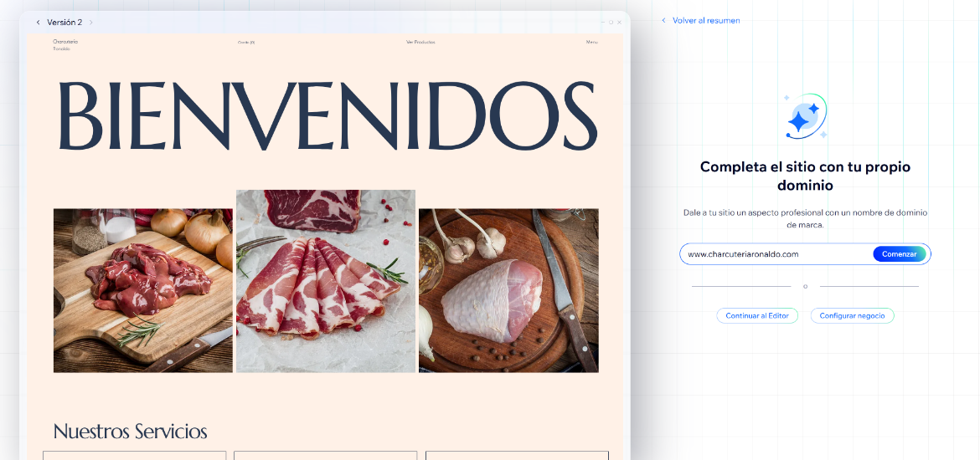

Now we will do the subpage or post in this case they are called services.

So we will do 3 services clicking on the button shown “Administrate services”.

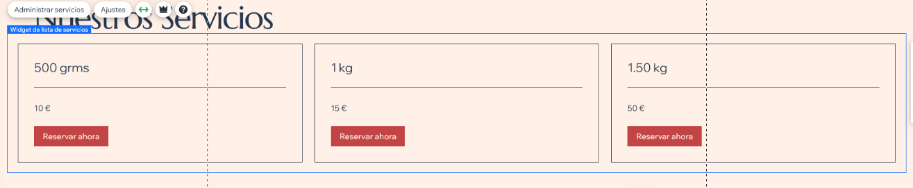

Here we created our 3 services which only selected the option of “change the price” also with a picture attached and a name.

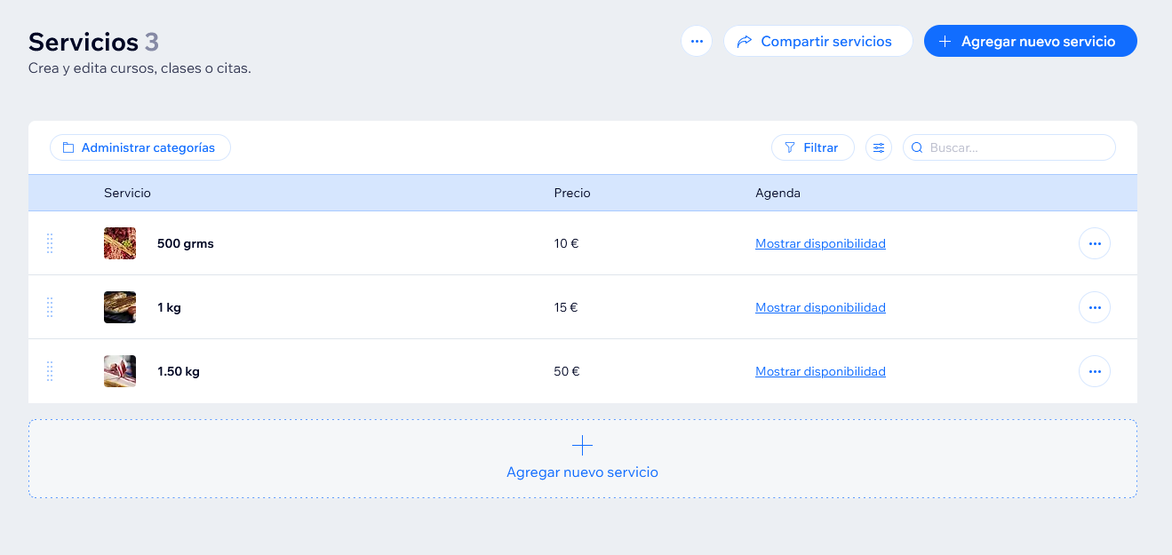

Then on the left-up corner of the page we are in we click on “Site -> Home”.

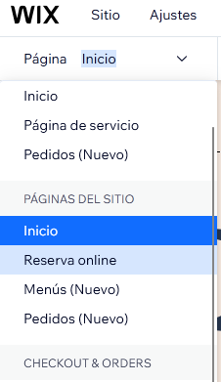

After that our services will be updated if we move to the Home page.

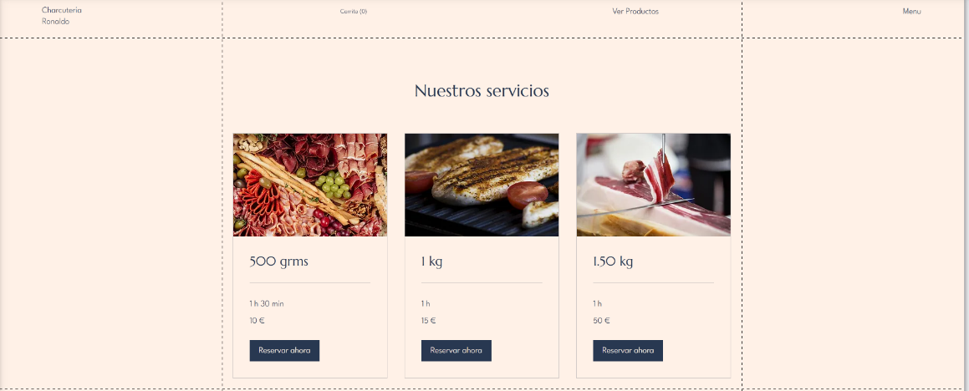

So we now have a Menu on the home page to see our main services.

When all is finished, we click on save and publish our website, and… Voilà our page is published and ready to see for everyone.





If you want to see how my page looked like… This is the link:  
<https://adrianmvpc.wixsite.com/charcuteria-ronaldo>